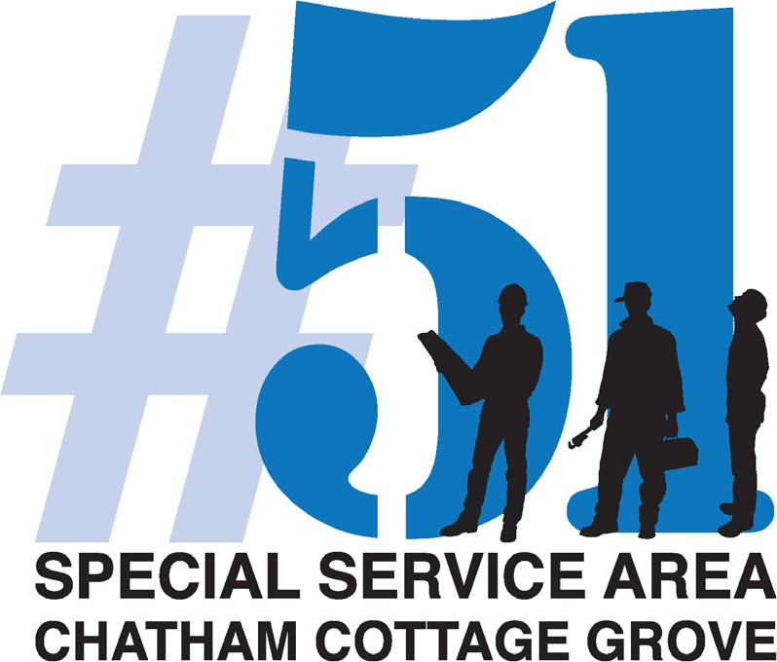

REPORT: Summary of Services

Prepared for Commissioners Open Meeting
June 14th, 2023
Prepared by
SSA #51 Service Provider
Chatham Business Association, Small Business Development Inc.

1.

SSA 2024 Budget:

See 2023 Budget Summary

2.

Advertising and Promotions
Important information, such as Business Certification, Financial Assistance and Technology Development are distributed regularly to the SSA #51 businesses. Communications are sent to SSA #51 Businesses of SSA #51 Services, Monthly Membership Meetings, SSA Quarterly Meetings and IT Ambassador Program.

SSA #51 Service Provider executed a Mix n Mingle, April 27,2023

Total in attendance: 85

SMS Message
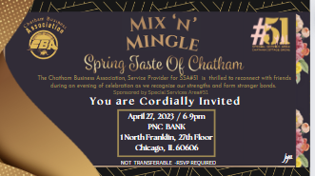

Email Marketing
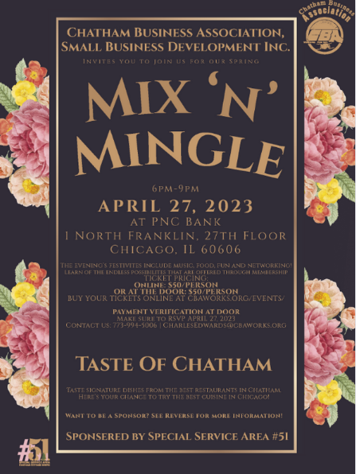

Business of the Month-June2023

Business of the Month-May2023

Business of the Month-April 2023
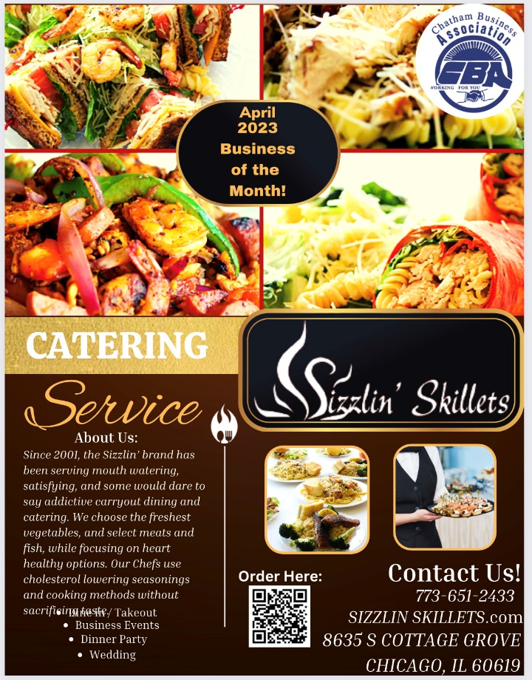
April 2023 - Flyer
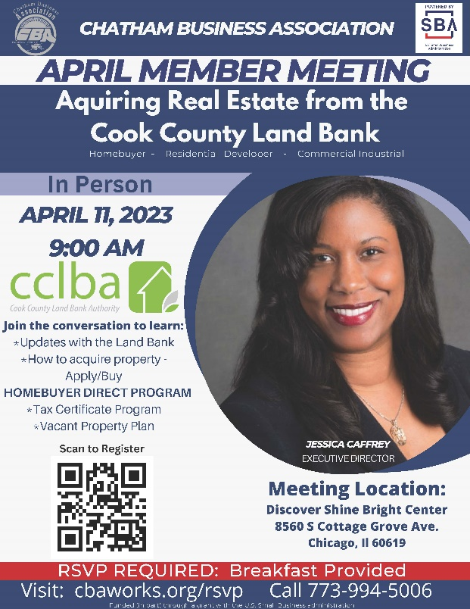

https://forms.gle/SVA2aXWPo9vAMKfA6

CBA, SBDI is also adamantly promoting the SSA businesses on their social media.
CBA will promote SSA #51 business deals and promotion on their Social Media sites (Facebook.com/ @ChathamCottageGroveSSA51 Instagram: Followers (@Chathamcottagessa51)
15 posts, 61 followers, 14 following. The following flyers have been promoted.
Did You Know Project Update by SP Program Manager Karletta Kelly: 2nd quarter Interviews include: Sizzlin Skillet, Dats Donuts, Solo Beauty Supply, Misunderstood Natural Hair Salon, Professional Electronics, R.B Pest Control Obessed Boutique and CombatZone.

3.

Public Way Maintenance
March 2023 – June 2023

Street Cleaning
Between April and June 5th, a total of 906 bags (52 Gallon bags) of garbage were collected. In other words, 15,004 Gallons of garbage have been collected and removed from the streets of SSA #51 in the last three months. We lost one street cleaning staff member and hired a new staff member.

Areas within the SSA #51 that were cleaned include: 75th Street (Indiana to Drexel), 79th Street (Cottage to 95th Street), 79th Street (Greenwood to Indiana), Cottage Grove (75th Street to 95th Street), and Vacant lots located on 75th Street, 79th Street, 95th Street and Cottage Grove Avenue. Reported by Cliff Borner, SSA 51 Field Program Manager

2023 2nd Quarter Photo Link

Public Works – CDOT
- Street resurfacing:
75th Street – St. Lawrence to Martin Luther King

- New Walk ways:
Martin Luther king Drive and Cottage

Snow Removal:
The SSA #51 businesses will be surveyed in order to find out the timings they would prefer their snow to be removed. The survey options will include the following: 8:30AM and Noon and Noon – 3:00pm, There was no Snow Removed reported this quarter.

Bobcat Theft:
A police report has been filed for the stolen bobcat. The equipment was stolen from the CBA /Help at Home Parking Lot at 80078th street Sunday, April 9, 2023. Help at home cameras show that the theft happened during daytime hours between. It was discovered missing the following Monday, April 10, 2023.

The Bobcat not been located. The rental company, filed an insurance claim for the loss.

We are currently getting quotes for rental opportunities with other rental companies.

4.

Public Way Aesthetics
SSA #51 Service Provider will promote the SSA# 51 businesses corridor with Banners, Custom Trash Containers and Planters. Five Custom Trash Receptacles permits were renewed along with 6 Planters within the Corridor.

SSA #51 Businesses were surveyed about planter and Street Pole planters were favored overall. Based on City guidelines, CBA will draw up a plan for the best placement for planters. Negotiate replacement of damaged SSA 51 banners with Temple Display in accord with SSA#51 budget. Damaged banners per Field Supervisor are included: 6 on 95th, 19 on Cottage Grove from 75th and 95th, 12 on 79th St Corridor, and 9 on 75th St Service Provider RFP’s for Banner Vendor to replaced damaged banners. Service provider will utiize the relationship with the Chicago Art Institute to assist with the installation of the banners.

5.

Holiday Decorations
Service Provider will begin sourcing and negotiating Holiday décor, Input is requested on the following options:

Run Time: (November 1– January 1)

1.Pole Banners
💬1 - Pole Banners | Light Pole Banners - Square Signs

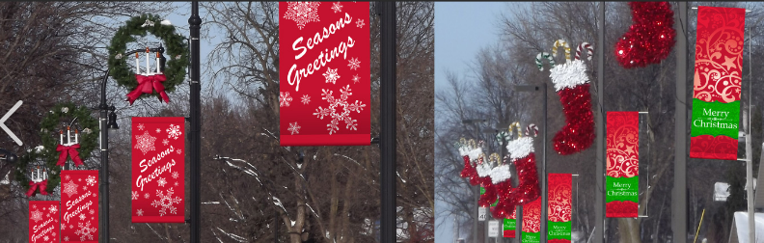

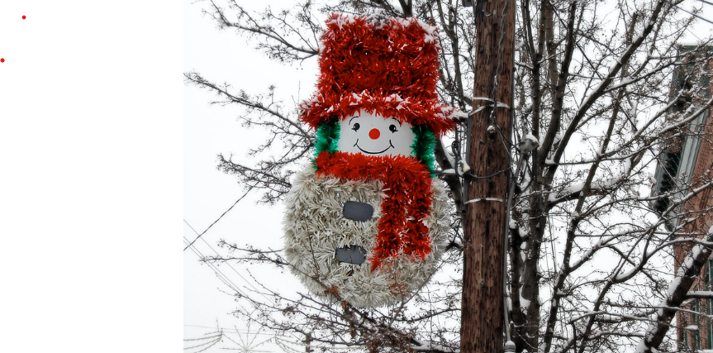

Wreaths on poles (placement would be on every 2nd pole)
We have the wreaths , we would need to purchase bows and pole attachments
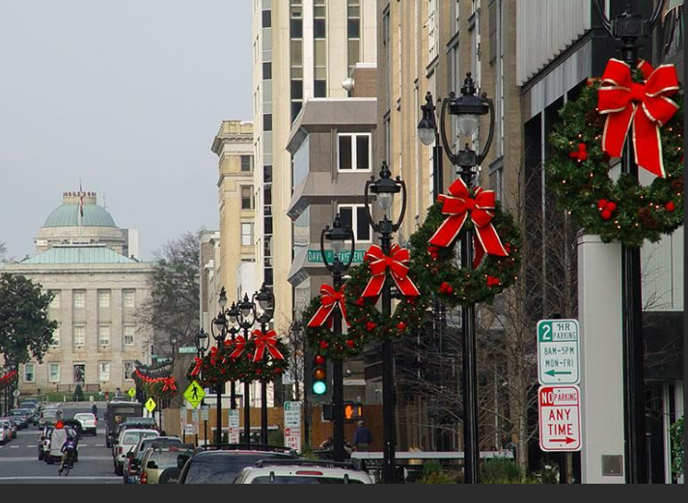

Candy canes
Ribbons

purchase and installation for 2023 Holiday install.

6.

Façade Improvements
No New projects this quarter.

7.

Safety Programs
CBA, SBDI contracted AGB Investigative for Special Event Security. Aggression
Sensor Program is currently on pause.

8.
Reports
Vacant Building Report
Marketing Plan for real estate in the corridors:
SSA 51 Marketing Plan for Commercial Real Estate.docx - Microsoft Word Online (live.com)

9.
New Ideas and Business

New Alderman for the 6th Ward

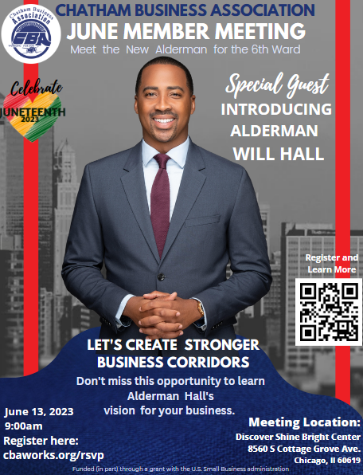

IDA Chatham Tour
2023 Annual Conference - International Downtown Association

Quick Reference Finance Guide:
CBA Quick Reference Funding Guide

Wal-Mart Academy
WalMart Academy Proposal

State of Illinos- State of Black Business Survey Findings
https://dceo.illinois.gov/omee/businessresourcelibrary.html

Choose Chicago Neighborhood Tourism Convention (Participation)
2nd Annual Choose Chicago Neighborhood Tourism Conference Tickets, Tue, Jun 6, 2023 at 12:30 PM | Eventbrite

Art in Corridors

Chicago Art Institute -FREE TICKETS THROUGH 12/31/2023
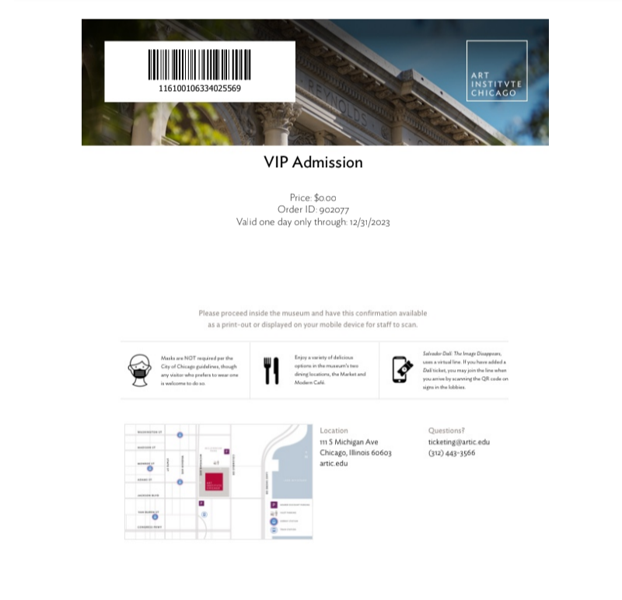

Partnership with Northwestern

We are teaming up with Northwestern Social Medicine Department to find ideal locations to place various types of art, permanent and temporary. Below are images that the Northwestern team provided as examples that were created in previous projects:

